11/6/2024

Group G

Semester IV - Cybersecurity

Implementation Report

Secure Solution: Malware Detection

# Table of Contents

Table of Contents 1

Introduction 2

Summary 2

Objectives 2

Scope 3

Within Scope 3

Out of Scope 3

System Architecture 3

Overview 3

Diagrams 4

Network Diagram 4

Database Diagram 5

Components 5

Virtual Machines Summary 5

Firewalls 8

Antivirus Software 8

Host-based Intrusion Detection System (HIDS) 8

Network-based Intrusion Detection System (IDS) 9

Implementation Details 9

Setup and Configuration 9

Development Process 27

Testing (”Wait for lauching the malware”) 27

Results 28

References 28

# Introduction

## Summary

This document outlines the implementation details for a cybersecurity project developed as part of a group effort in a cybersecurity course. The project focuses on creating a secure environment for a hospital setting, drawing inspiration from the 2017 NHS WannaCry ransomware attack. The goal is to design a secure environment and implement security measures to protect hospital networks from similar threats. We aim to ensure the safety of sensitive patient data.

The project leverages a combination of Virtual Machines (VMs) running Linux servers and Windows VPN workspaces. Key components of the secure environment include the deployment of antivirus software, configuration of firewalls with specific rules, and the integration of Host-based Intrusion Detection Systems (HIDS) and Network-based Intrusion Detection Systems (IDS). Through this comprehensive approach, the project aims to demonstrate effective strategies for malware detection and overall network security in a healthcare context.

This document details the setup and configuration processes for each security measure we took. Here, we will be providing instructions regarding the steps we took to create a secure environment. The implementation aims to offer a practical guide for protecting healthcare environments from cyber threats, ensuring both data security and operational continuity.

## Objectives

The main objective of this project is to design and implement a complete cybersecurity framework, tailored to a hospital envrionment. It is inspired by the NHS WannaCry ransomware attack of 2017. The goals we aim to achieve are as follows:

* **Enhance Security**: Establish a multi-layered securite architecture to protect a hospital’s network infrastructure from malware, ransomware, and other cyber threats.
* **Virtualized Envrionments:** Set up Virtual Machines to simulate the hospital network, using Linux servers and Windows workspaces that utilize a VPN for remote employees. This will be the base of our implemented solution.
* **Antivirus Solutions:** Implement antivirus software on all stations to ensure malware is detected.
* **Firewalls:** Implement firewalls, then create rules to control network traffic in a manner that prevents unauthorized access.
* **Intrusion Detection Systems:** Implement both Host-based Intrusion Detection Systems (HIDS) and Network-based Intrusion Detection Systems (IDS) to monitor network activity and identify security breaches.
* **Simulated Attack:** Simulate malware being released into the secure envrionment. This is to test that our solution does what it set out to do: detect and mitigate against malware.
* **Documentation:** Create documentation throughout the process.

## Scope

The focus of this project is to design and implement a secure solution to Malware, specifically in a healthcare envrionment. It involves a comprehensive framework of cybersecurity features. The scope is as follows:

### Within Scope

* **Virtual Envrionment Setup:** Virtual Machines are configured, using Linux servers and Windows workspaces for employees to simulate a hospital environment.
* **Antivirus:** Installation and configuration of antivirus software on all VMs to detect and mitigate malware threats.
* **Firewall Configuration:** Firewall implemented with added rules to prevent unauthorized access.
* **Intrusion Detection Systems:** HIDS and IDS will be deployed to fully monitor network activity.
* **Malware Attack Simulation:** This is essentially for testing our secure solution against malware.

### Out of Scope

* **Physical Security Measures:** We are only able to focus on cyber-threats. Details such as securing the actual building and equipment is out of our scope.
* **Employee Training:** While we strongly suggest training your employees to detect phishing attacks and other cyber threats, this is out of our scope.
* **Compliance Certification:** We are not able to get any formal compliance certifications, such as HIPAA certification.

# System Architecture

## Overview

The system architecture for our cybersecurity project is designed to manufacture a secure environment for a simulated hospital network. The architecture uses a combination of Virtual Machines (VMs) and security tools to replicate a real-world healthcare setting, providing a platform for implementing and testing our chosen cybersecurity measures. This design includes multiple layers of defense and specialized components to ensure the safety of the sensitive data NHS is in possession of.

The system is segmented into several key components, each playing a critical role in the overall security posture. The components are distributed across different VLANs to simulate a realistic network segmentation strategy, improving both security and manageability.

## Diagrams

### Network Diagram

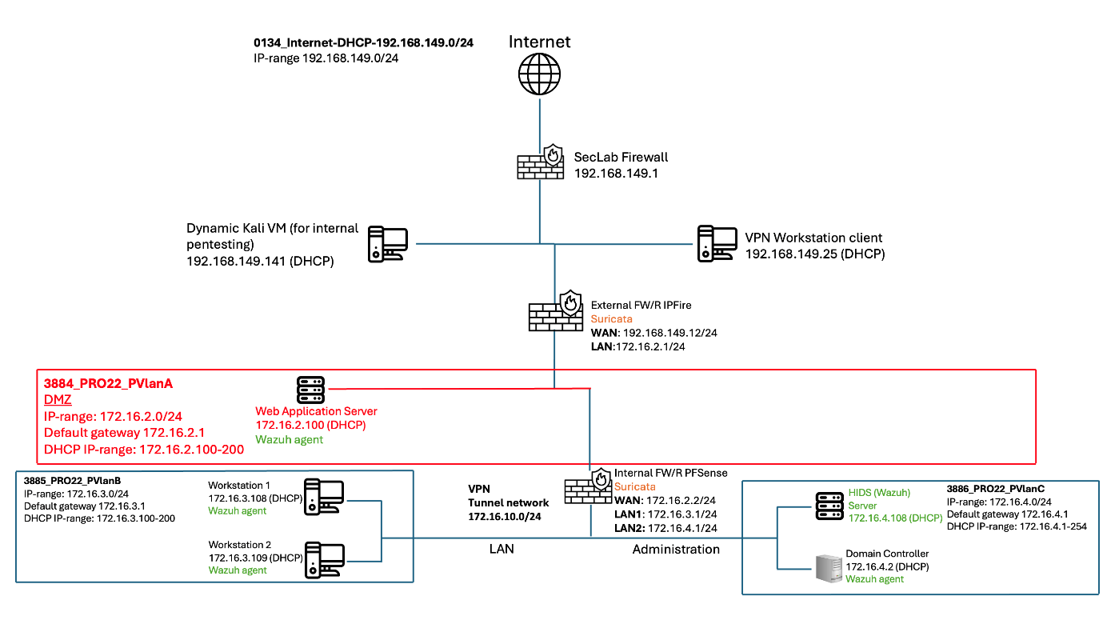

This is the network diagram we have constructed to simulate our full envrionment.

Internet-DHCP: 192.168.149.0/24  
IP-range: 192.168.149.0/24

SecLab Firewall: 192.168.149.1

Kali VM: 192.168.149.141 (DHCP)

External Firewall FW/R IPFire:  
WAN: 192.168.149.12/24  
LAN: 172.16.2.1/24

PvlanA:  
DMZ  
IP-Range: 172.16.2.0/24  
Default gateway: 172.16.2.1  
DHCP IP_range: 172.16.2.100-200

Web Application Server  
172.16.2.100 (DHCP)  
WAF (ModSecurity)  
Wazuh Agent

HIDS (Wazuh) Server:  
172.16.2.101 (DHCP)

Linux Workstation:  
Wazuh Agent  
172.16.2.102 (DHCP)

### Database Diagram

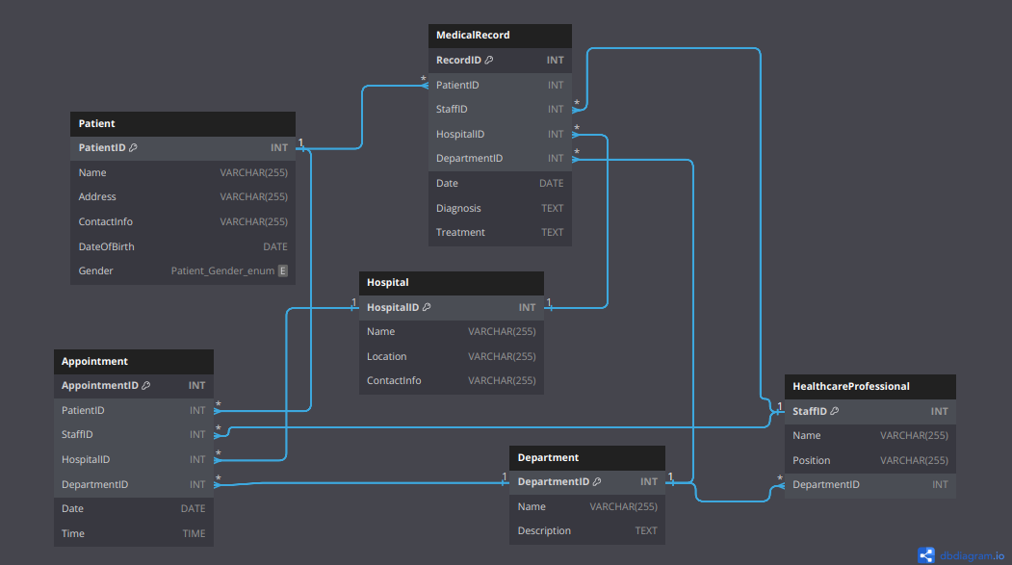

Our proposed database diagram setup for our simulated hospital web application.

## Components

### Virtual Machines Summary

Here, I will give a breakdown of our entire VM setup and explain the function of each one.

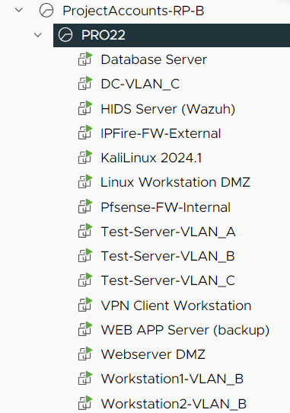

#### Database Server

* **Purpose**: Hosts the database for the hospital's web application.
* **Technology**: Uses Kubernetes for container orchestration. This exists here to host the web applications database.

#### DC-VLAN_C

* **Role**: Domain Controller.
* **Technology**: Utilizes Microsoft Windows DNS Server Service for domain name resolution and network management, providing centralized authentication and directory services.

-Group Policies would go here

#### HIDS Server (Wazuh)

* **Role**: Host-based Intrusion Detection System (HIDS).
* **Technology**: Wazuh, which monitors system integrity, logs, and behaviors to detect and respond to suspicious activities on the hosts.

#### IPFire-FW-External

* **Role**: External Firewall.
* **Technology**: IPFire, configured to filter incoming and outgoing traffic, protecting the network from external threats. It forms the first line of defense in our two-firewall setup.

#### Kali Linux 2024.1

* **Role**: Security Workstation.
* **Technology**: A Kali Linux workstation located on the DMZ. This is the machine we can use and move across the whole environment. We are using this for testing the environment.

#### Pfsense-FW-Internal

* **Role**: Internal Firewall.
* **Technology**: Pfsense, configured to monitor and control internal traffic, ensuring security within the network and providing a second layer of defense.

#### Test Servers

* **Test-Server-VLAN_A**: Located on private VLAN_A for testing security measures and configurations. May be deleted in the future when they are no longer needed.
* **Test-Server-VLAN_B**: Located on private VLAN_B, another test server. May be deleted in the future when they are no longer needed.
* **Test-Server-VLAN_C**: Located on private VLAN_C, our last test server. May be deleted in the future when they are no longer needed.

#### VPN Client Workstation

* **Role**: Simulates remote employee access.
* **Technology**: Configured with DHCP and connected via VPN to securely integrate with the hospital's LAN, enabling remote access as if the device were within the internal network.

#### Webserver DMZ

* **Role**: Main Web Server.
* **Technology**: Hosts the primary web application and is located in the DMZ to segregate it from the internal network, enhancing security by isolating external-facing services.

#### Workstations (VLAN_B)

* **Workstation1-VLAN_B**: Simulated workstation representing an end-user device within the hospital's internal network.
* **Workstation2-VLAN_B**: Another simulated workstation located on the hospital LAN, used to mimic typical hospital workstations and their interaction with the network.

### Firewalls

#### IPFire

* **Purpose**: Serves as the external firewall in our two-firewall setup.
* **Technology**: IPFire is an open-source firewall solution known for its flexibility and robustness. It filters incoming and outgoing network traffic, protecting the network from unauthorized access and external threats. IPFire supports various security features such as intrusion detection, VPN support, and web proxy, making it an integral part of our network’s perimeter defense.

#### Pfsense

* **Purpose**: Acts as the internal firewall.
* **Technology**: Pfsense is an open-source firewall and router software based on FreeBSD. It provides comprehensive network protection by monitoring and controlling internal traffic, ensuring that only legitimate traffic flows within the network segments. Pfsense includes features like VPN, load balancing, and advanced packet filtering, which help secure the internal network against internal threats and lateral movement of malware.

### Antivirus Software

#### ClamAV

* **Purpose**: Provides antivirus protection for Linux-based systems.
* **Technology**: ClamAV (Clam AntiVirus) is an open-source antivirus engine designed for detecting trojans, viruses, malware, and other malicious threats. It is particularly suited for server environments due to its command-line interface and flexibility in integration with various applications. ClamAV scans files on-demand and can be scheduled to run at regular intervals to ensure continuous protection.

#### Windows Defender

* **Purpose**: Provides antivirus protection for Windows-based systems.
* **Technology**: Windows Defender is a built-in antivirus and anti-malware solution provided by Microsoft for Windows operating systems. It offers real-time protection, scanning, and removal of various types of malware, including viruses, spyware, and ransomware. Windows Defender integrates seamlessly with the Windows operating system, providing automatic updates and comprehensive security features to protect against evolving threats.

### Host-based Intrusion Detection System (HIDS)

#### Wazuh

* **Purpose**: Provides host-based intrusion detection and security monitoring.
* **Technology**: Wazuh is an open-source security monitoring platform. It provides HIDS functionality, such as log analysis, file integrity monitoring, rootkit detection, and real-time alerts. Wazuh collects and analyzes data from many sources, analysing events to detect suspicious activities and security breaches. It also integrates with various security information and event management (SIEM) systems to provide a unified view of security across the network.
* **Wazuh dashboard should be accessible anywhere on the LAN**.

### Network-based Intrusion Detection System (IDS)

#### Suricata

* **Purpose**: Provides network-based intrusion detection and prevention.
* **Technology**: Suricata is an open-source network IDS, IPS, and network security monitoring engine. It inspects network traffic based on established rules to detect threats. Suricata works in real-time to identify and respond to suspicious activities on the network. It supports deep packet inspection, protocol analysis, and has capabilities to log HTTP, DNS, TLS, and many other protocols, making it a powerful tool for detecting a wide range of network-based attacks.

# Implementation Details

## Setup and Configuration

This section of the document aims to provide detailed steps for setting up and configuring each component in the environment. The implementation of all the components is based on the following user stories:

**Healthcare Provider Staff:**

1. As a healthcare provider staff member, I want the system to encrypt patient data in our databases so that confidentiality is maintained, and we comply with privacy regulations.
2. As a healthcare provider staff member, I want the network traffic to be monitored for any suspicious activity or potential security threats so that the IT team can be notified immediately for investigation.

**IT Team:**

1. As an IT team member, I want the system to update all software and security patches regularly so that vulnerabilities are mitigated, and the risk of exploitation by cyber attackers is minimized, ensuring system security.
2. As an IT team member, I want the system to securely transfer patient data between different healthcare facilities or external partners using encrypted communication protocols so that data breaches during transit are prevented, ensuring patient data privacy.
3. As an IT team member, I want to view a network diagram of the cybersecurity solution so that I can understand how the system is structured and how data is protected.
4. As an IT team member, I want the system to utilize two different firewalls to enhance security measures and safeguard our network.
5. As an IT team member, I want the system to employ a robust system hardening approach to strengthen the security posture of our infrastructure, reducing the risk of vulnerabilities and unauthorized access.
6. As an IT team member, I want the system to implement segmentation to create isolated network segments, allowing for granular control over network traffic and minimizing the impact of potential breaches.

**System Administrators:**

1. As a system administrator, I want the system to conduct regular malware scans on our current software to detect and remove any malicious programs or files, ensuring the integrity and safety of our data.
2. As a system administrator, I want the system to include domain controllers to manage user authentication and authorization efficiently, ensuring secure access to network resources and applications.
3. As a system administrator, I want the system to deliver good performance to ensure that our critical applications and services run smoothly and efficiently, minimizing downtime and disruptions to our workflow.
4. As a system administrator, I want sensitive data to be accessible only on the hospital VLAN to maintain confidentiality and compliance with privacy regulations, preventing unauthorized access from external networks.
5. As a system administrator, I want the system to provide endpoint protection to secure devices connected to our network, defending against malware, ransomware, and other cyber threats that may target endpoints.

#### IPFire

Note: Since IPFire does not exsist as a template in the vsphere environment. We had to download it and create it locally and then upload it as OVA format to the vsphere environment.

1. Visit IPFire download page and download the appropriate ISO image file.
2. Create a VM locally using the downloaded ISO file.
3. Convert the created machine to OVA format using a tool called OVFTool.
4. Upload the created OVA file to the vsphere environment and deploy it.
5. Configure the machine:
   * Setup network interfaces:
     + Green: Internal network interface (Default GW).
     + Red: External network interface.

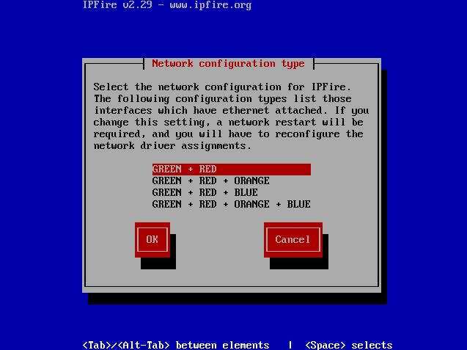

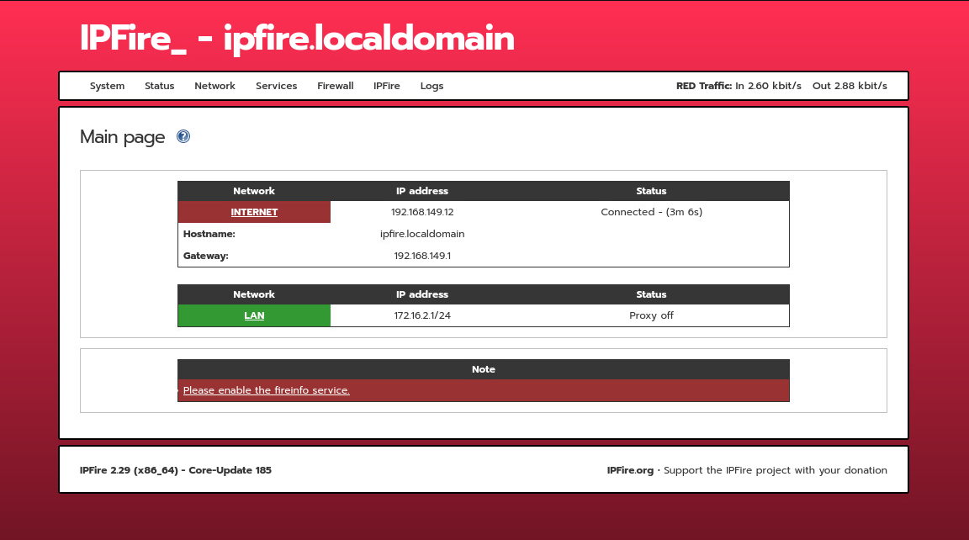

* + Configure DHCP for the internal interface:

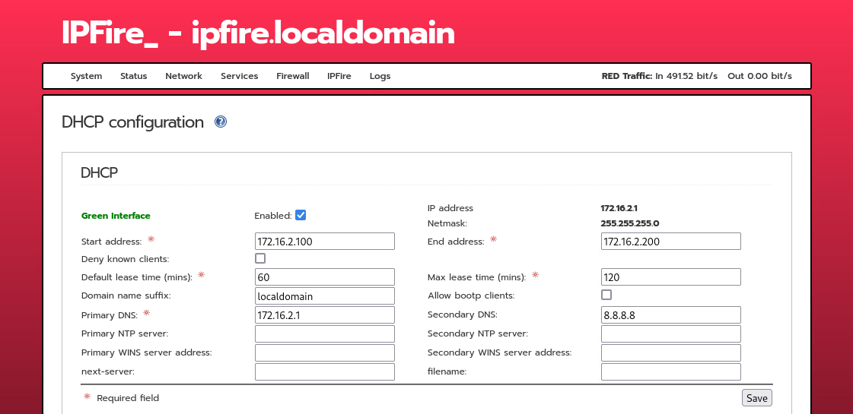

* + Configure the external interface to use the Netlab’s DHCP:

Note: This interface should not have DHCP enabled to avoid any conflicts.

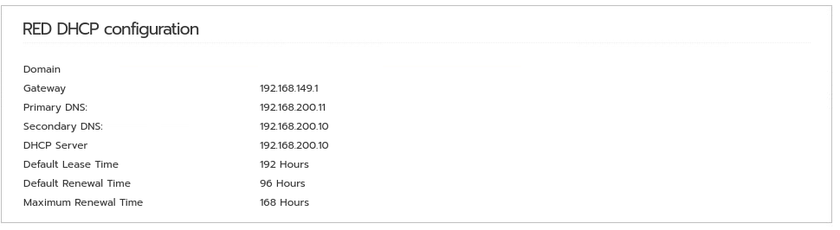

* + Add Firewall Rules to allow traffic on ports 443 (Webserver) and 1194 (OpenVPN):

Note: the OpenVPN server is running on the internal firewall (PFsense) and intended for remote employees.

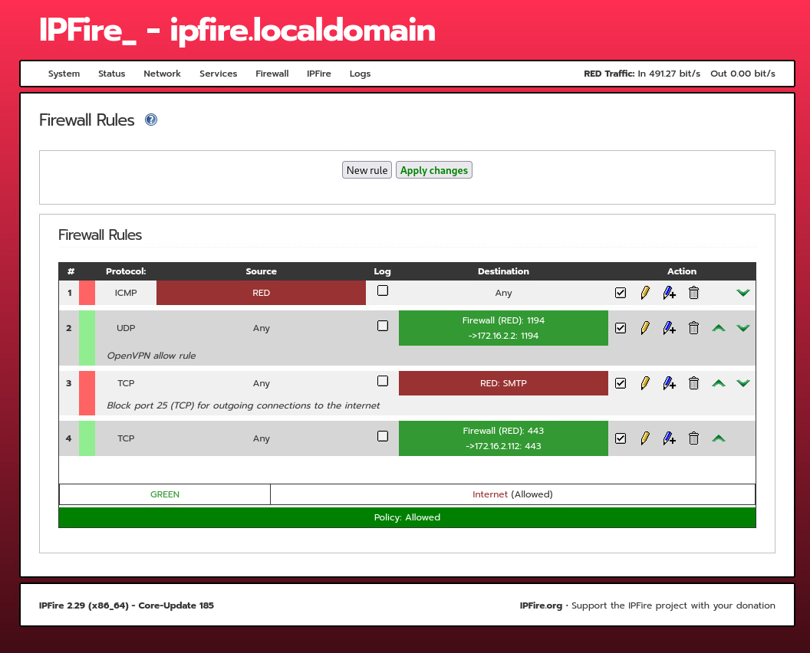

* + Setup Intrusion Prevention System with various rulesets to monitor both of the interfaces.

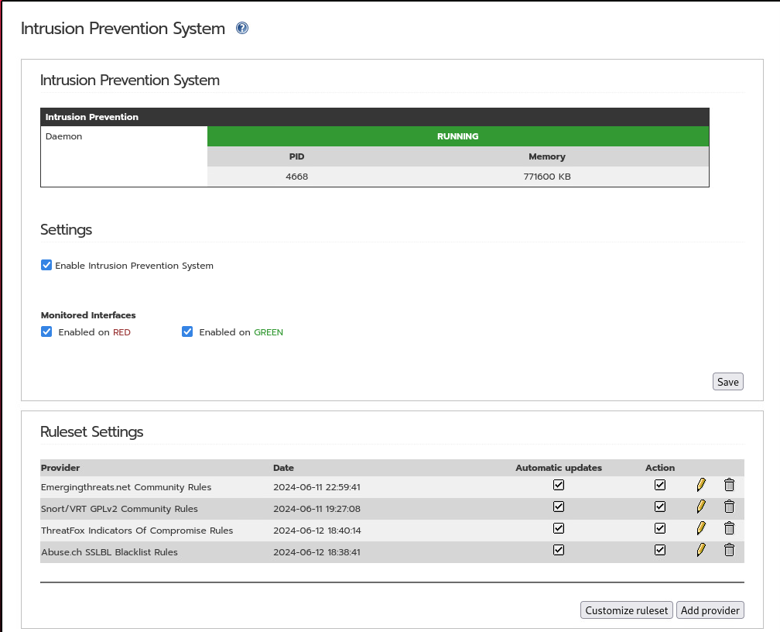

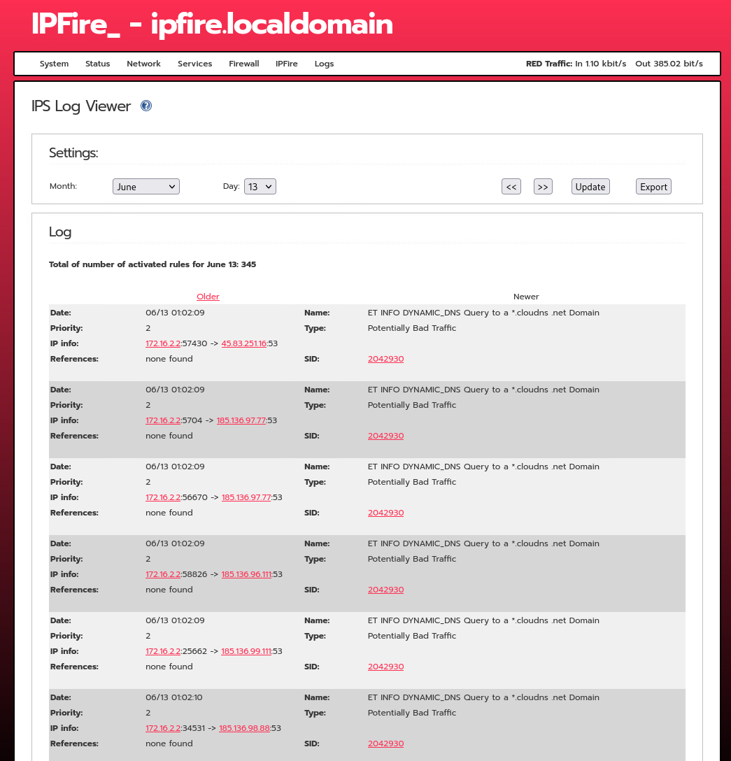

#### Pfsesne

1. Deploy Pfsense from a template in the vsphere environment.
2. Configure the machine:
   * Setup network interfaces:
     + WAN: DMZ facing interface.
     + LAN: Employees LAN (where workstations reside).
     + ADMINISTRATION: Where monitoring systems and DC reside.

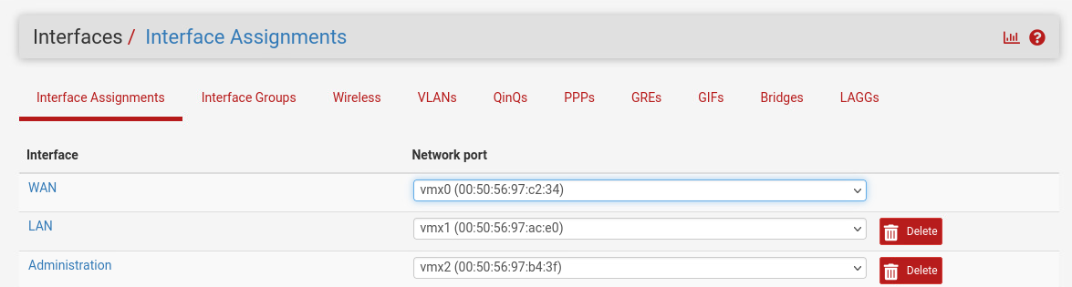

* + Enable DHCP for the LAN and ADDMINISTRATION interfaces:

Note: The WAN should not have DHCP enabled to avoid any conflicts .

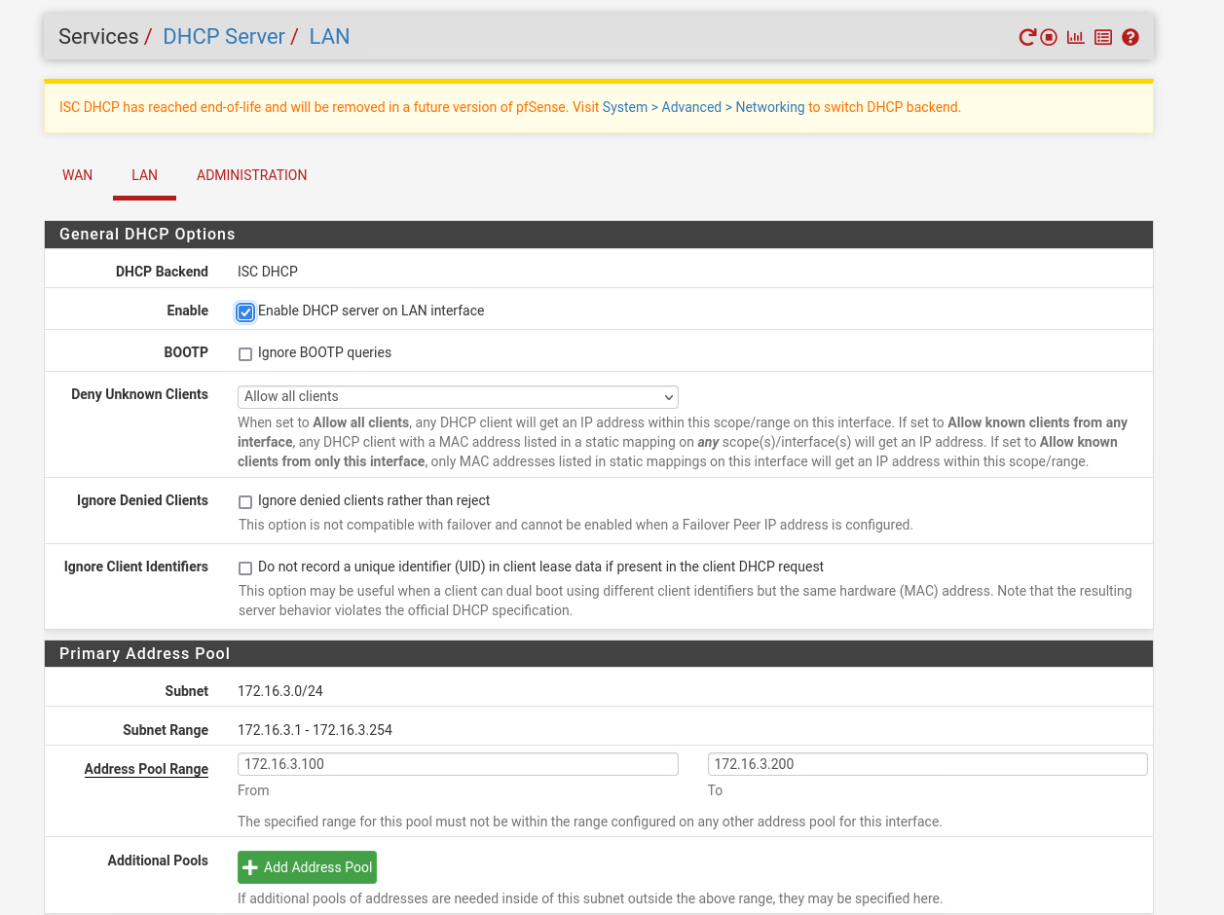

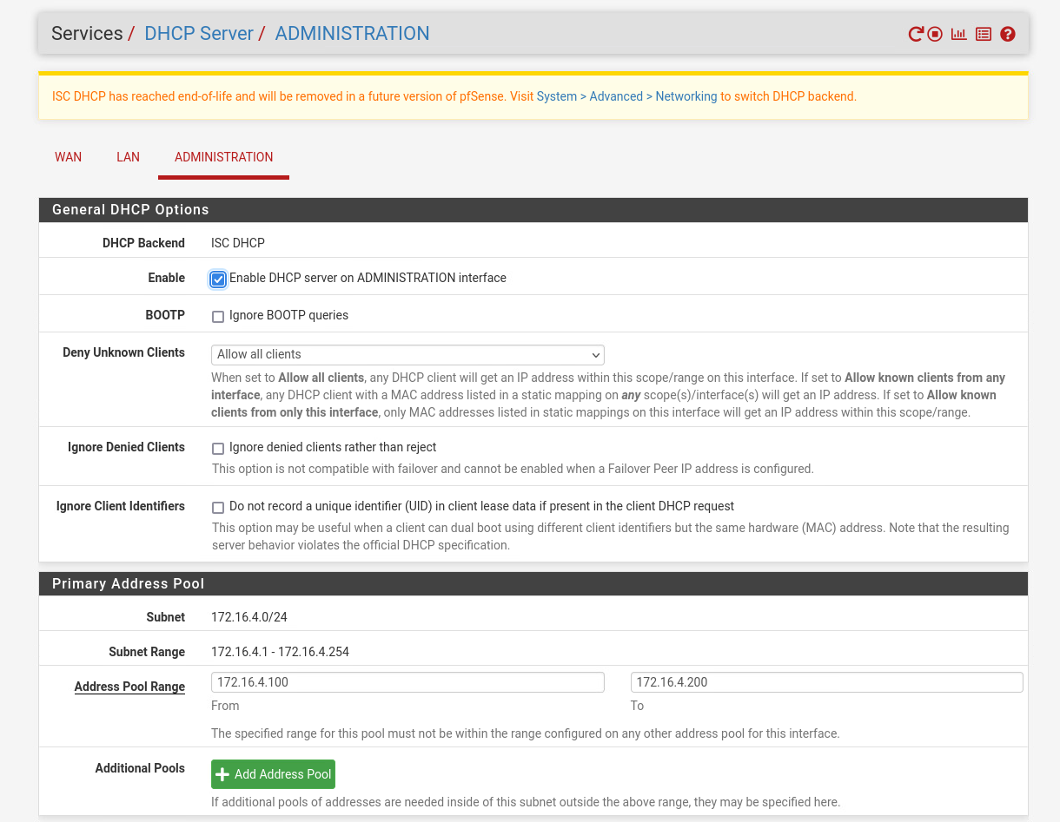

* + Setup Suricate (IDS/IPS) with varios rule sets to monitor both the LAN and ADMINISTRATION interfaces:

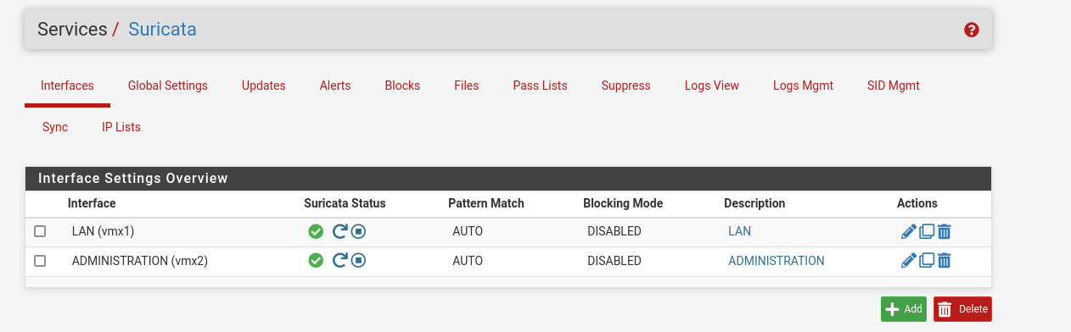

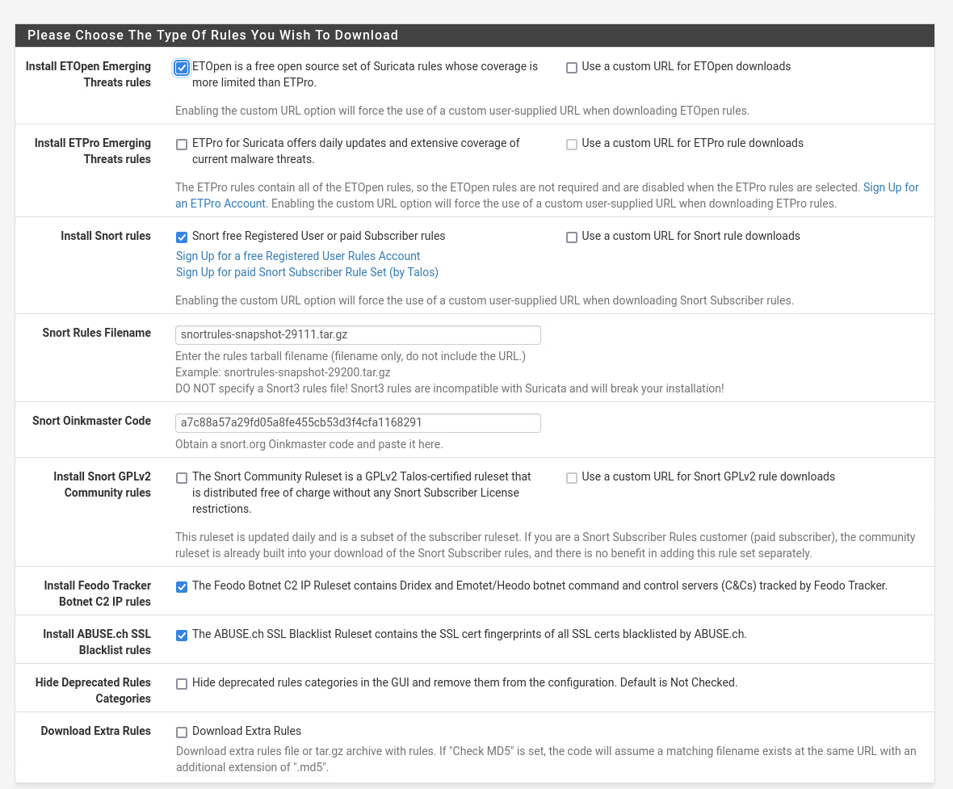

* + Select the desired rules for both of the interfaces:

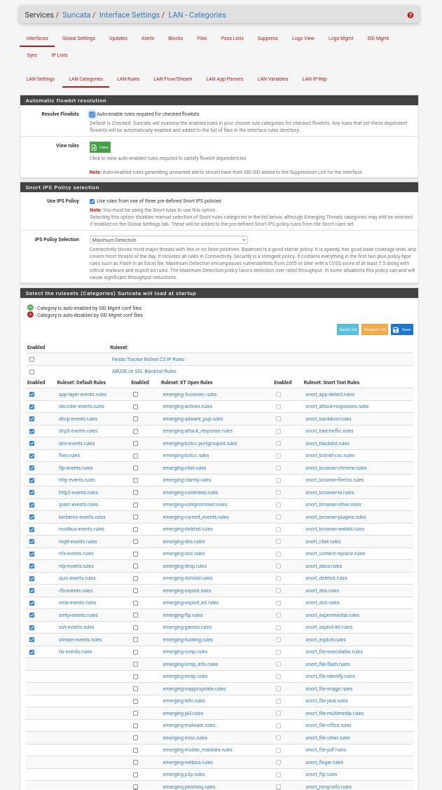

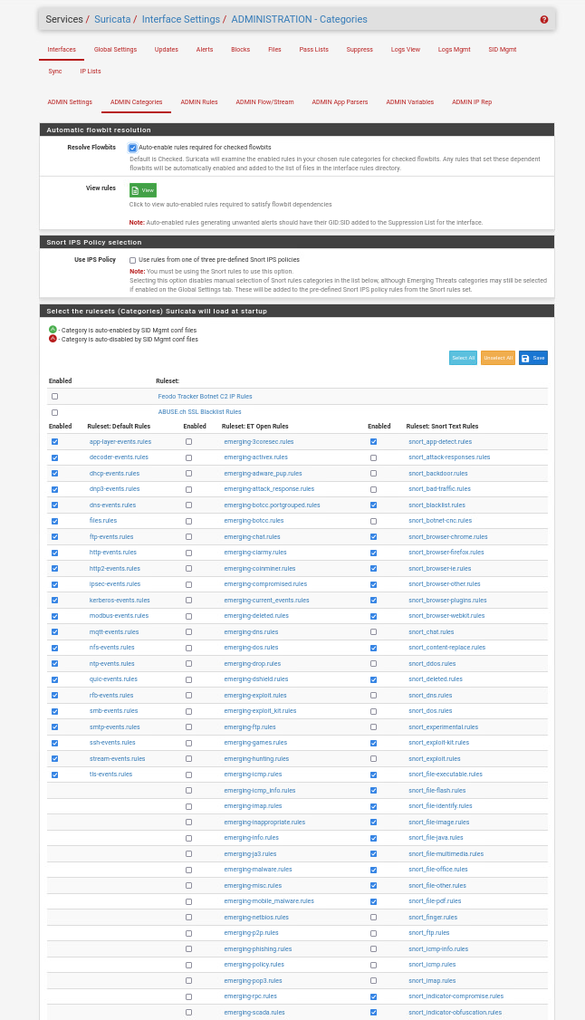

* + Firewall rules are configured for each interface based on the services running in the environment, with the purpose of each rule noted in the description section:

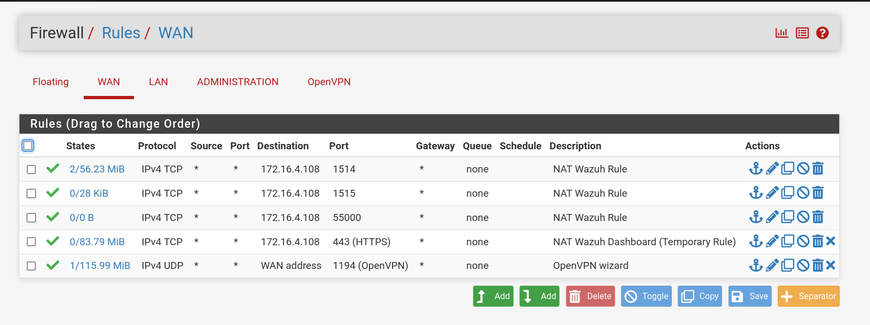

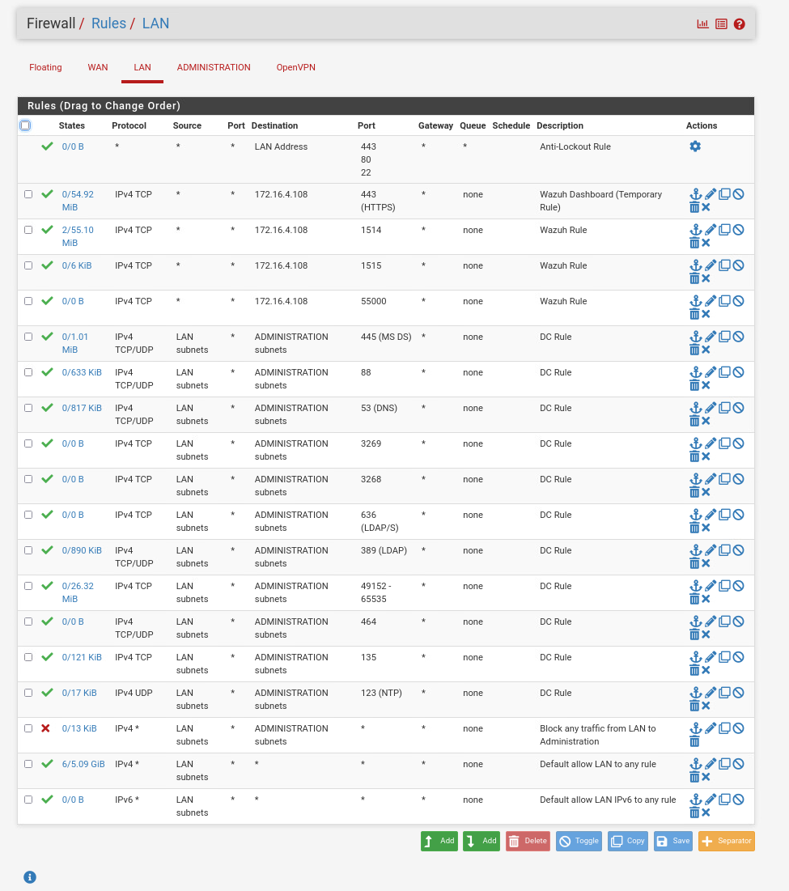

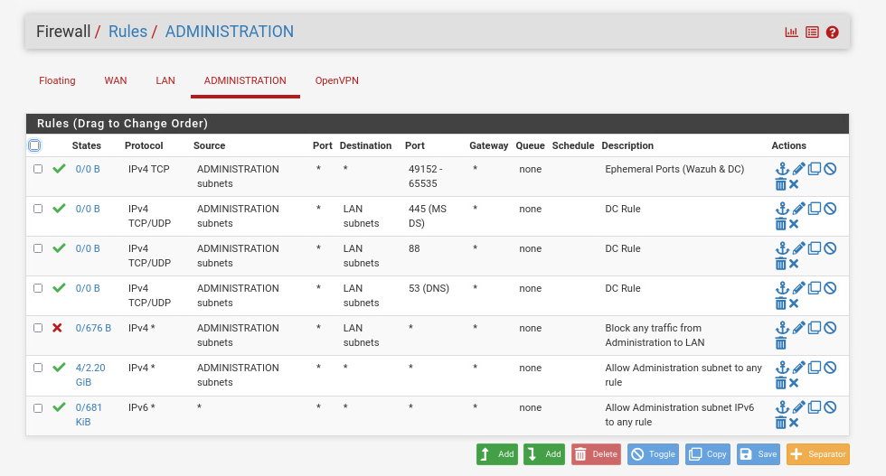

* + In setting up OpenVPN on pfSense for secure remote access, the process involves creating a Certificate Authority (CA), configuring the OpenVPN server, setting up user authentication, and applying necessary firewall rules.

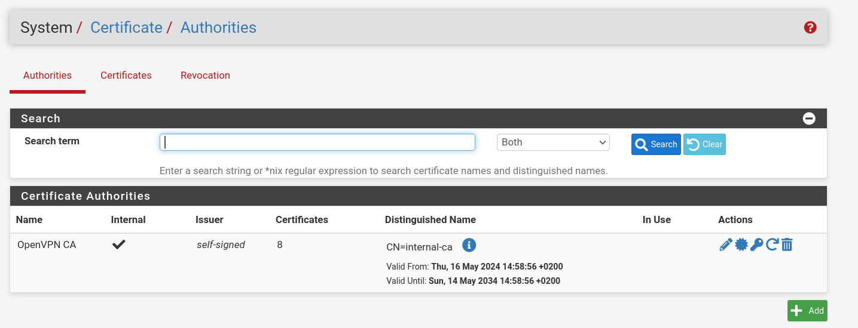



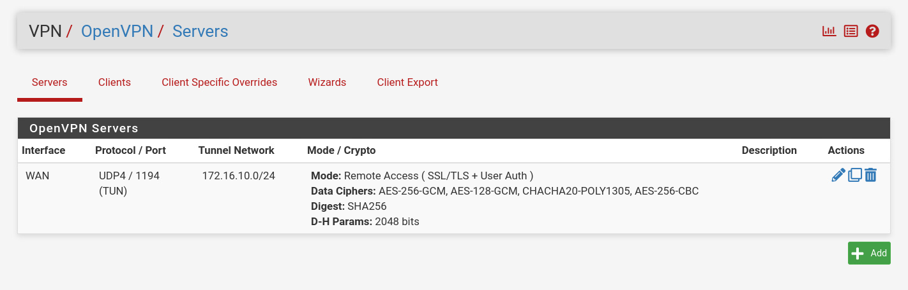

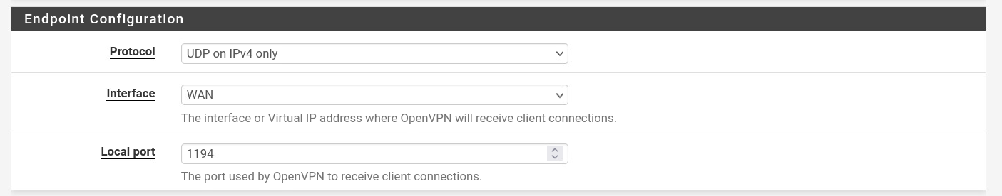

* + - Grant Access to the DMZ and LAN subnets:

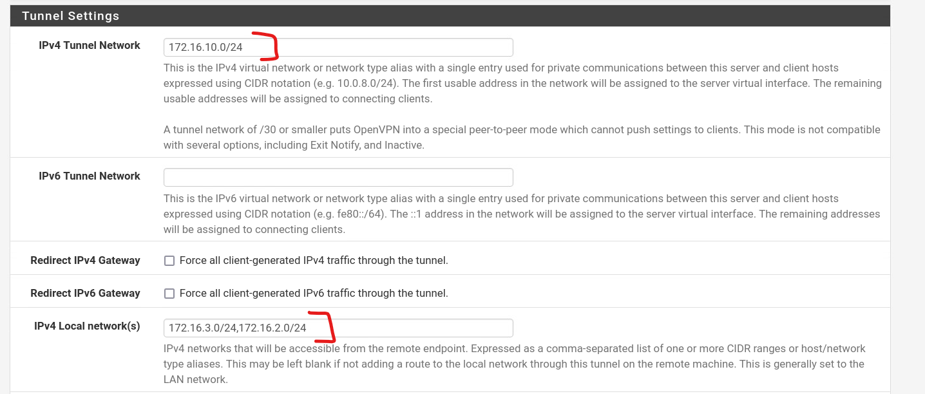

* + - Install the client export package and create an account for every team member:

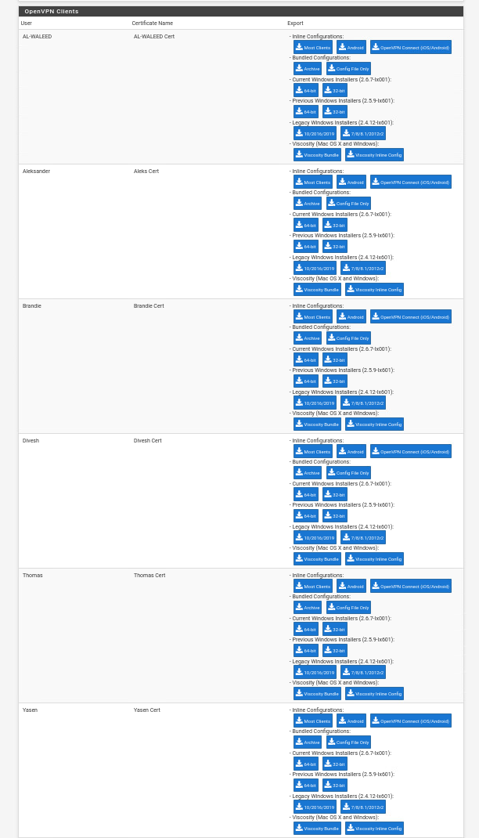

#### Domain Controller

Note: the Domain Controller serves as a DNS server and offers directory services, while DHCP functionality is handled by the firewalls.

* 1. Deploy Windows server from a template in the vsphere environment.
  2. Promote server to Domain Controller:
     + Open Server Manager.
     + Click on Add roles and features.
     + Select Active Directory Domain Services and install it.
     + Promote the server to domain controller using the Active Directory Domain Services Configuration Wizard, after installation.

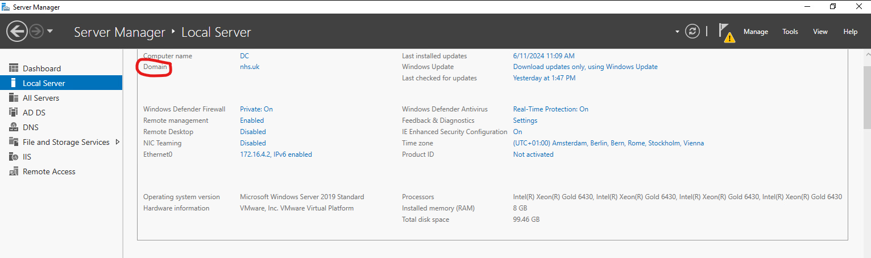

* 1. Configure DNS by ensuring that the DNS Server role is selected during setup.

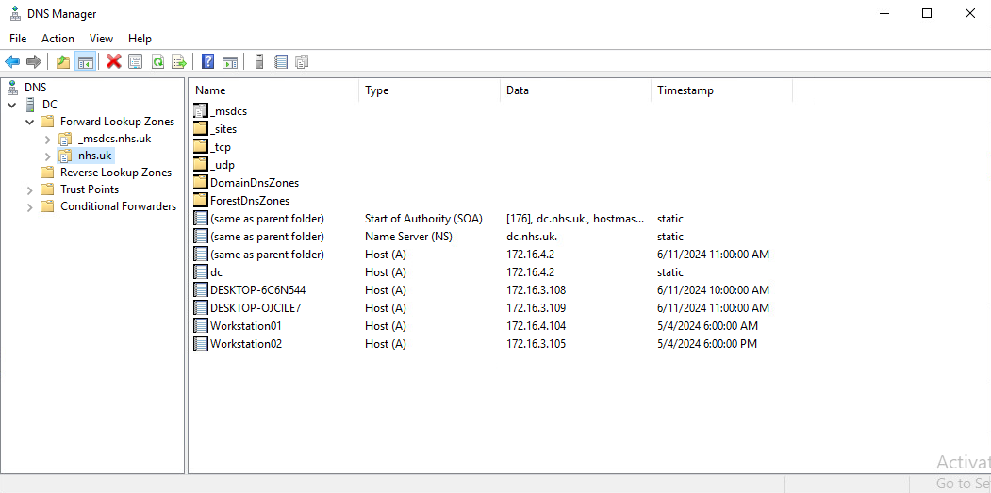

* 1. Manage Active Directory Users and Computers:
     + Added Workstations and User(s):

Note: crossed out computers were deleted.

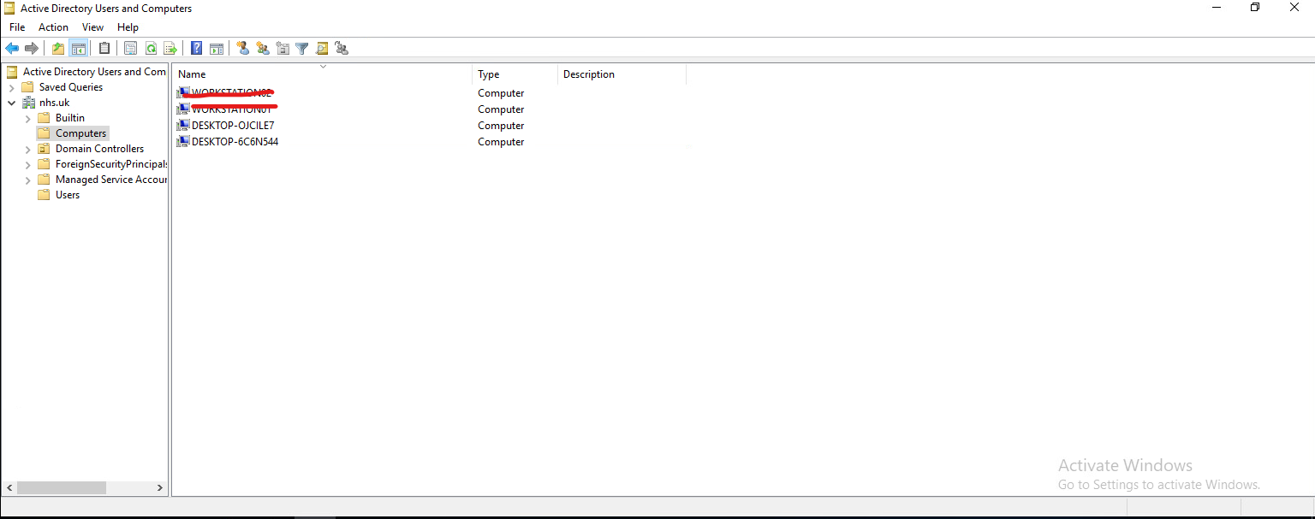

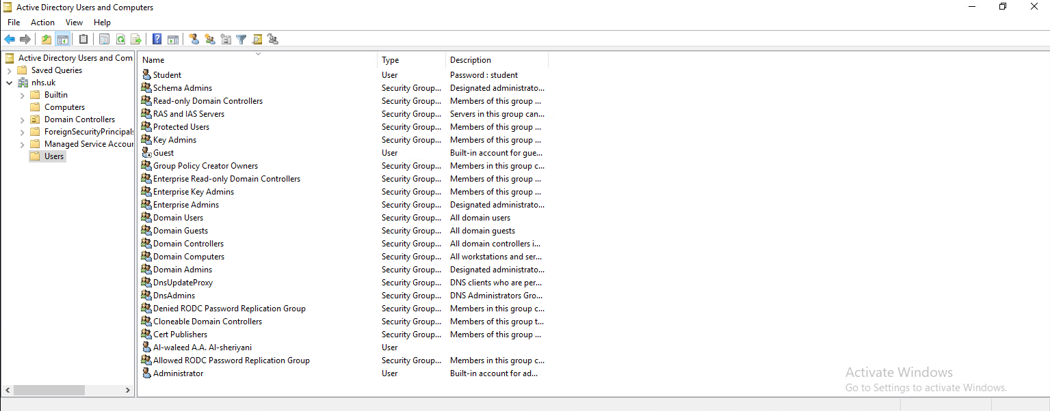

#### Group Policies on Domain Controller

1. Deploy the domain controller machine.
2. Open Windows Server Management.
3. Select “Tools” in the upper right corner.   
   From the drop-down menu, select Group policy management.
4. Open the document tree labeled “Forest: nhs.uk”, “Domains”, “nhs.uk”, and then select Group Policy Objects.
5. Right click inside Group Policy management and create new. The one I am creating is titled “NHS Security Policy”.
6. Right click on “NHS Security Policy” and select “Edit”.
7. Navigate to the appropriate sections and enable the rules you wish to implement.
8. Enforce password history to keep password history for the past 5 passwords.

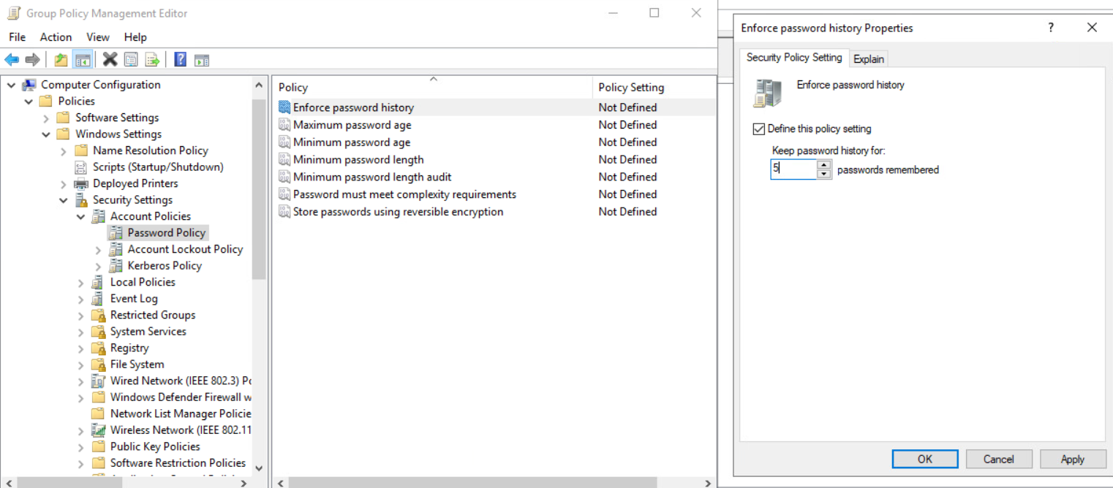

1. Make password complexity a requirement.

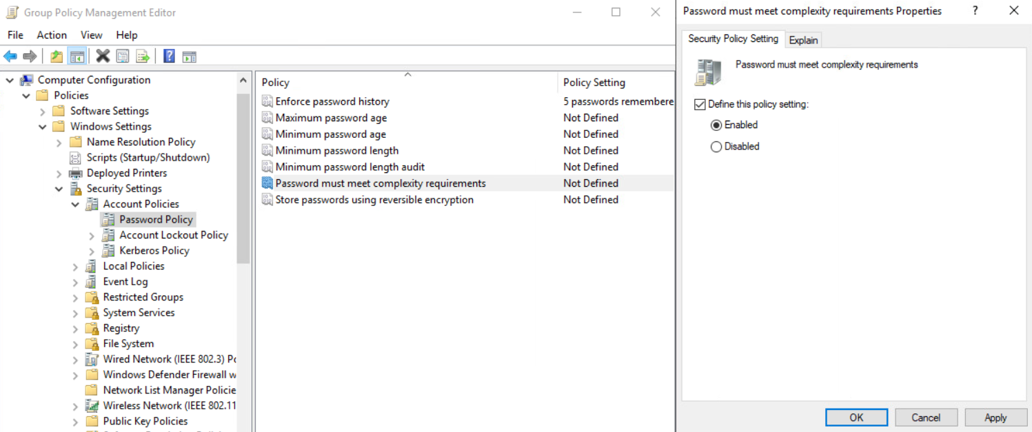

1. Ensure real-time protection is on, scan all downloaded files and attachments, and turn on behavior monitoring.

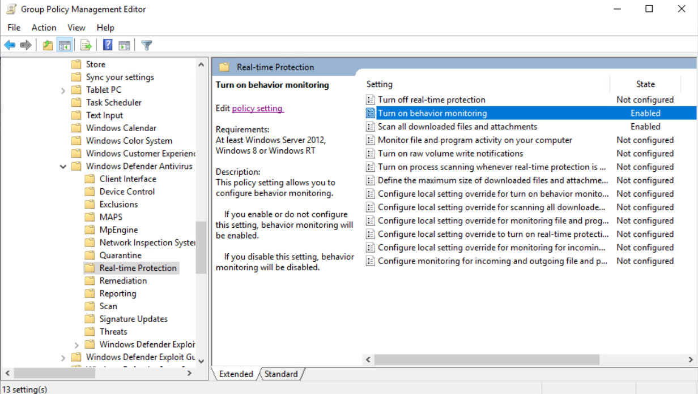

#### Workstation01 & Workstation02 (Joined to the domain)

* 1. Deploy a Windows machine in the vsphere environment from a template.
  2. Configure the DNS address to the IP of the domain controller.

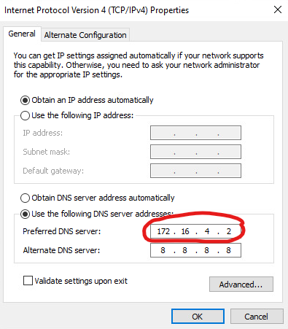

* 1. Join the machine to the domain:

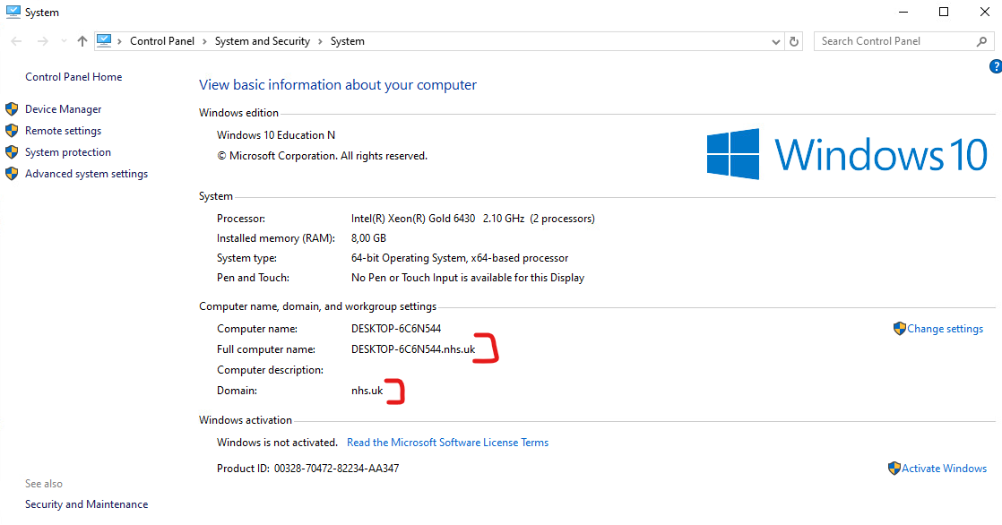

#### Wazuh HIDS

* 1. Download and install Wazuh Manager.

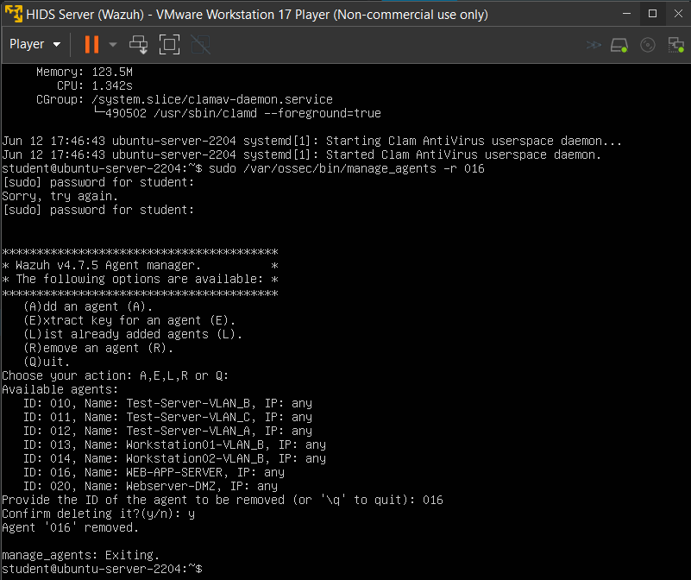

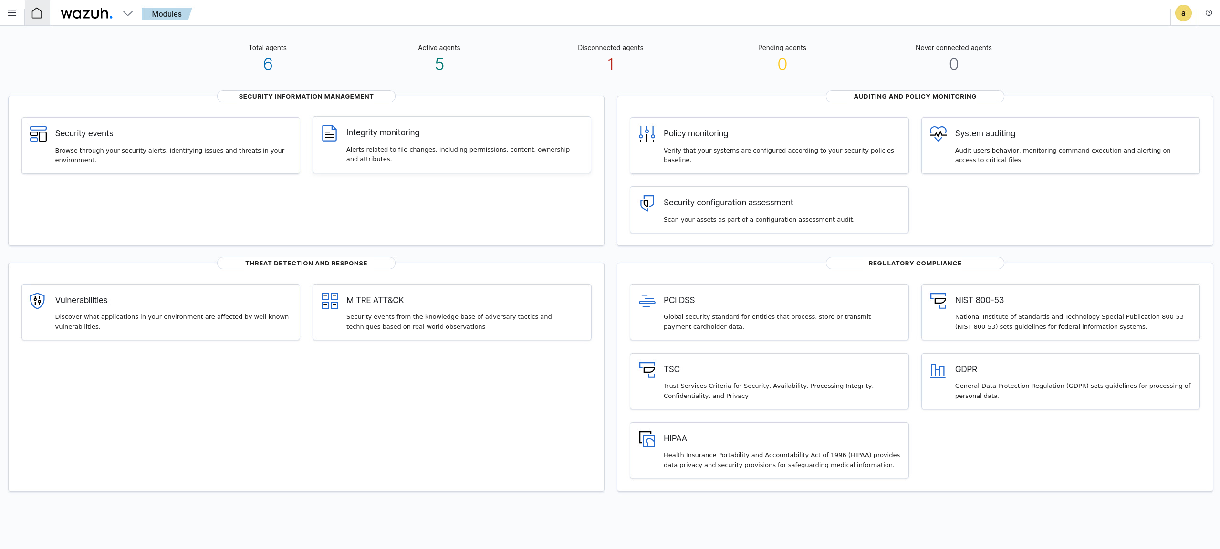

* 1. Deploy Wazuh Agents

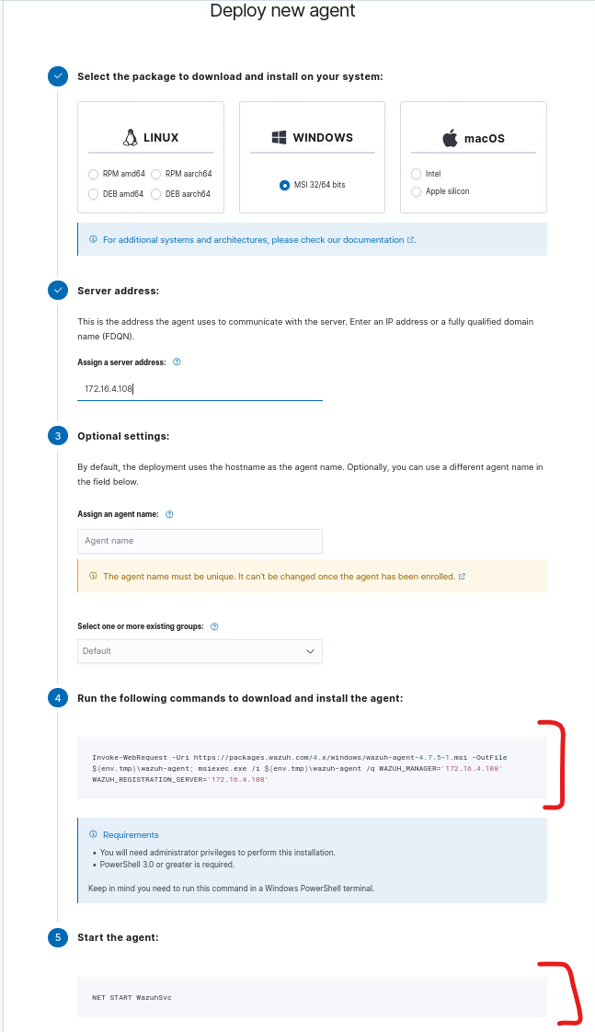

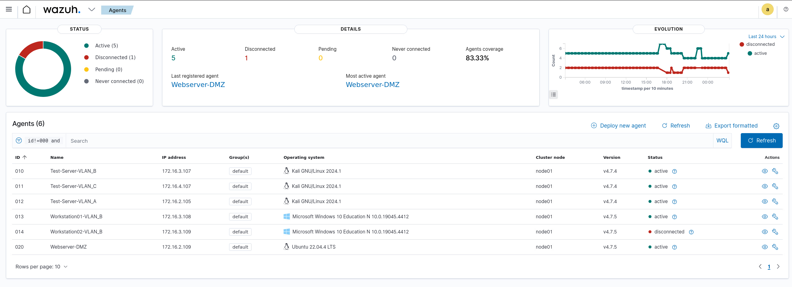

#### ClamAV

* 1. Install ClamAV daemon:

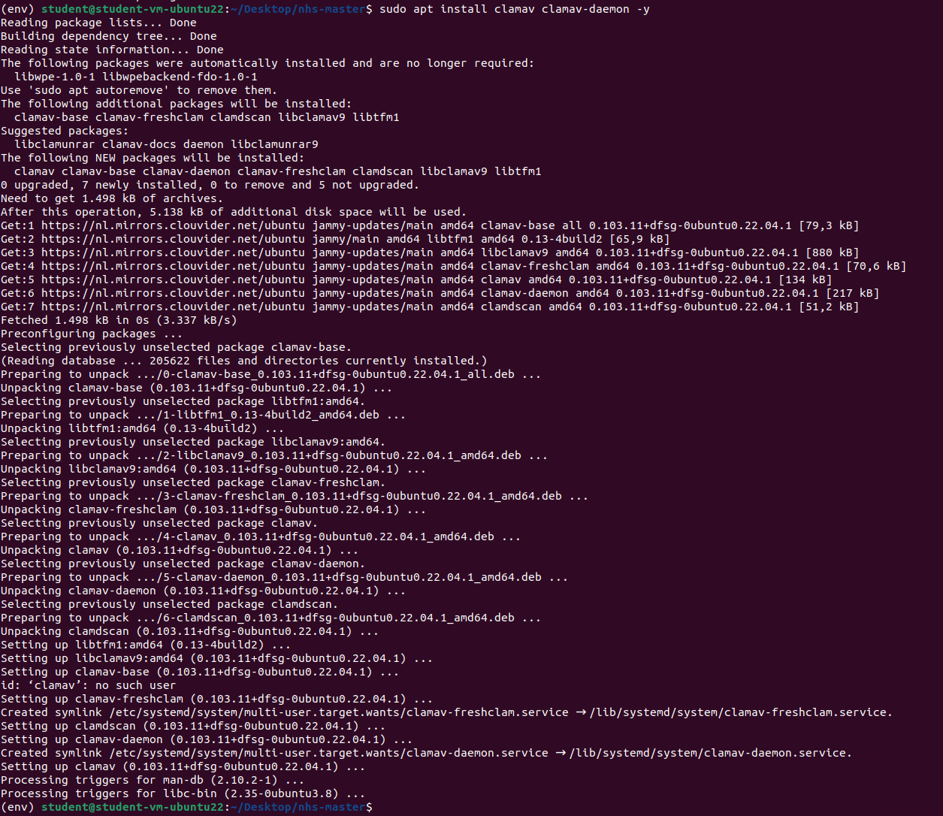

* 1. Start and enable the ClamAV Deamon

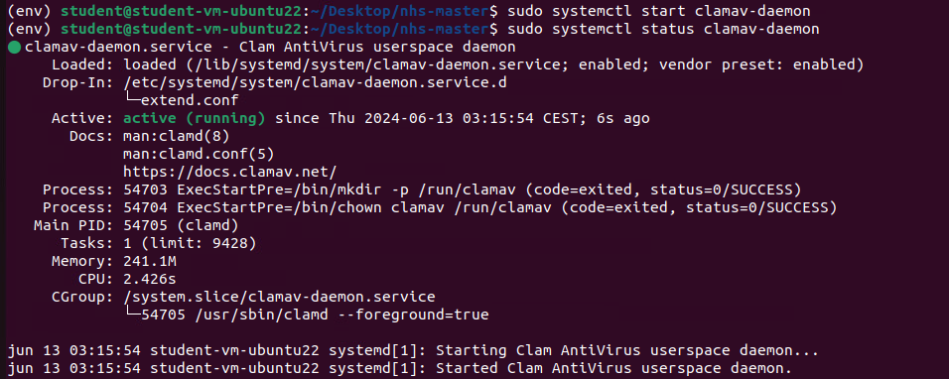

* 1. Performe a quick scan to test the software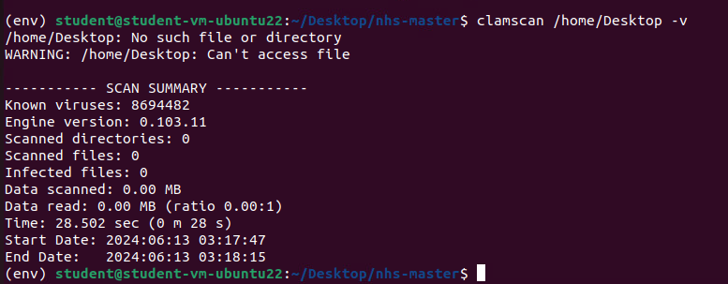

#### OpenVPN Client

1. Deploy a remote machine in the Netlab’s general network (DHCP).
2. Install OpenVPN client to connect to the OpenVPN server.

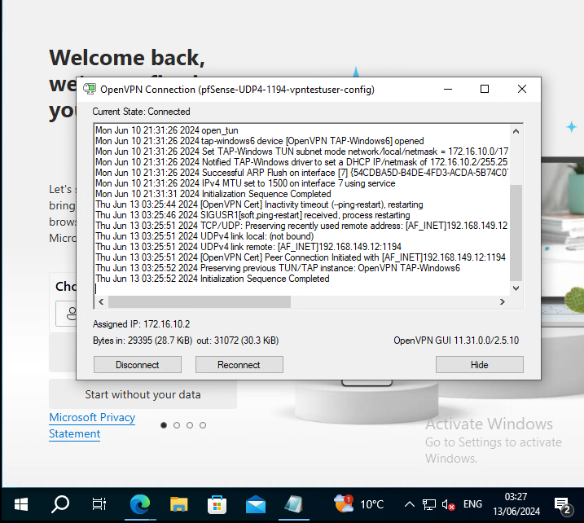

#### WebServer

* 1. Deploy an ubuntu machine from a template in the vsphere environment.
  2. Create a web application.

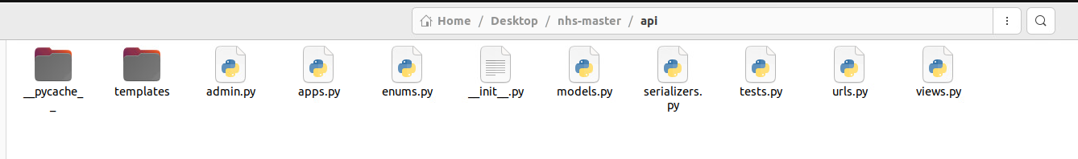

* 1. Set up a self-signed certificate to secure and encrypt traffic.
  2. Containerize and deploy the created app.

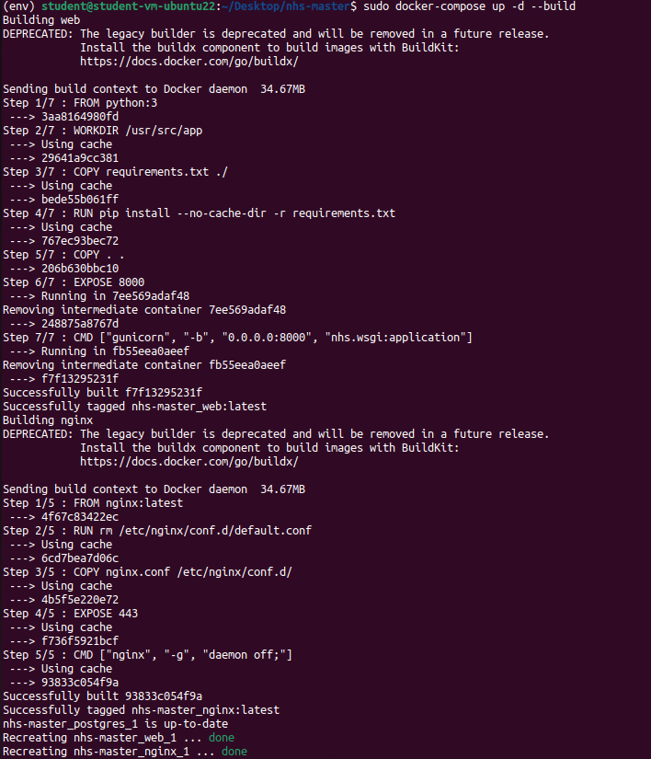



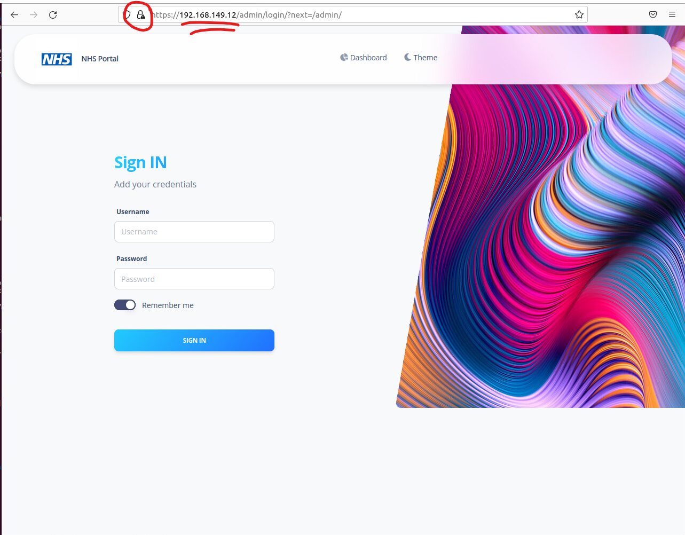

### Backup server:

* 1. Deploy and configure a backup server called UrBackup and backed up the most significant severs:

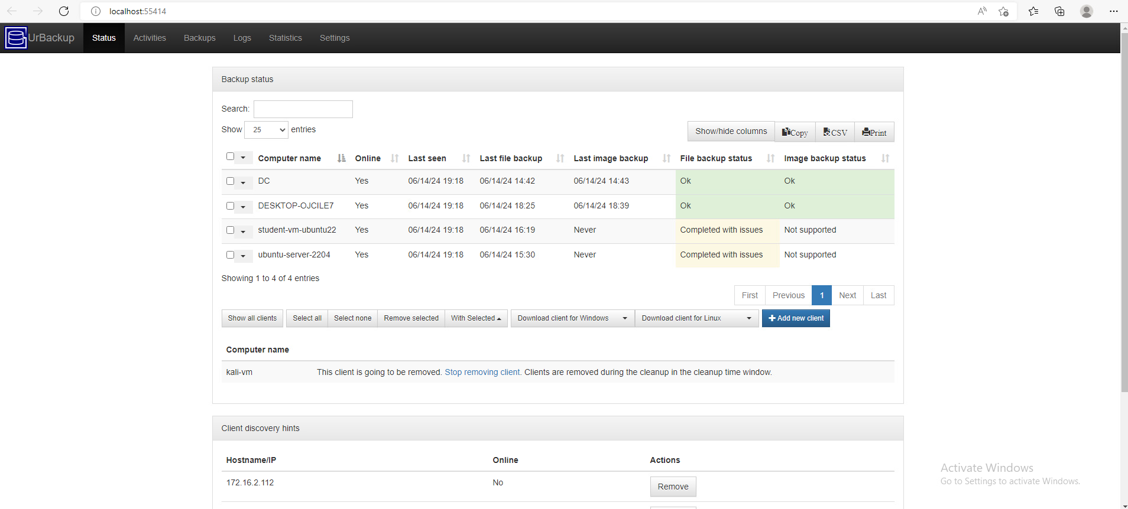



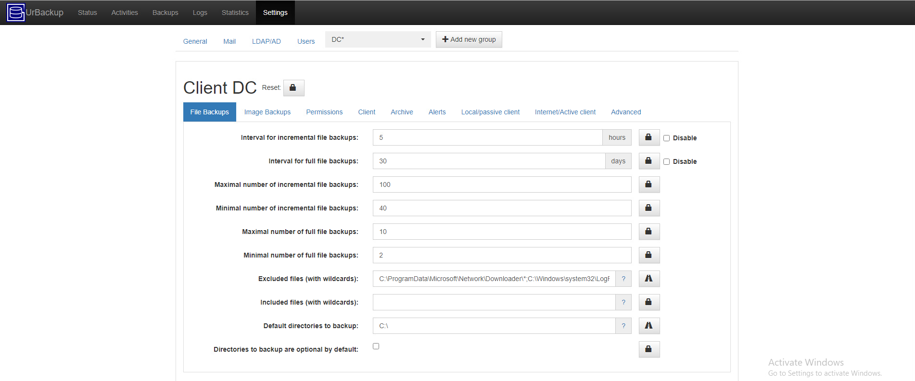



## Development Process

The project was implemented following the Scrum framework, specifically the agile methodology. All work was managed and assigned to team members using Jira, which helped us to track tasks, user stories, and sprint progress. Regular sprint planning, daily stand-ups, and sprint retrospectives kept us continuously improving and kept us working together as a team.

## Testing

* **Testing:**
  + Nmap scan results
  + Test cases and results.
  + Bug tracking and resolution.

### Network scanning

Using **Nmap**, a powerful network scanning tool, we performed a thorough scan of our network. The scan results showed that all 1000 scanned ports on the target host (172.16.2.1) were filtered. This effectively means that our secure solution is preventing such scans from gathering any additional information that could potentially expose details about our internal systems and the services running on them. The Nmap scan report reinforces the effectiveness of our security measures in shielding our network from unauthorized access and information disclosure.

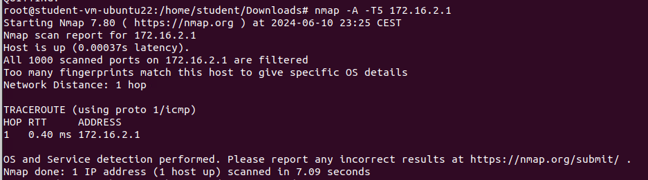

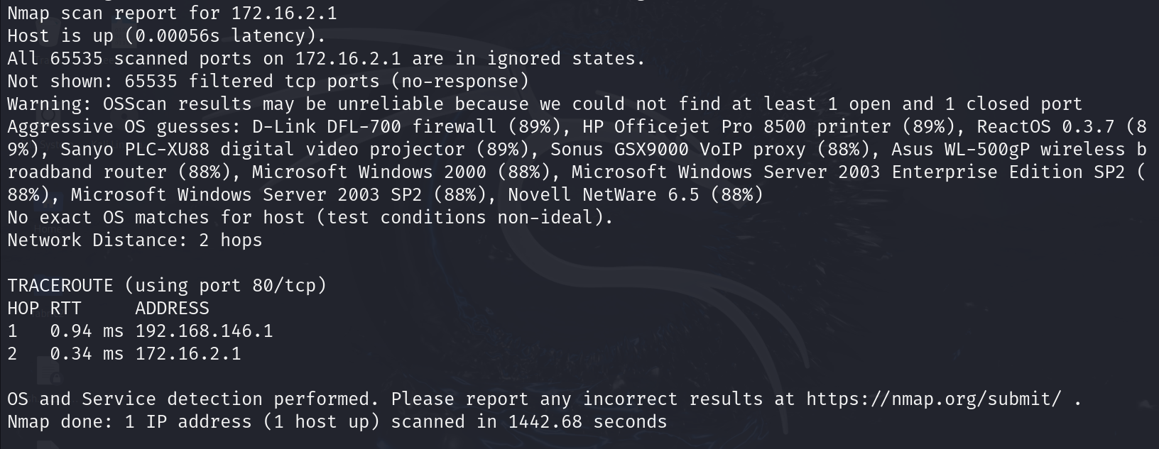

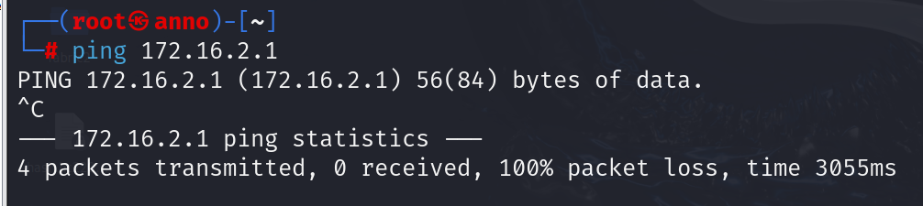

We have effectively applied a rule for outside machines that prevents them from even pinging our top-router/firewall. This ensures that we reveal as little information as possible about our network. The ping test, as shown in the screenshot, resulted in 100% packet loss for all packets transmitted to 172.16.2.1. This indicates that our firewall successfully blocks ICMP packets from external sources.

It is important to note that, contrary to our external firewall settings, our internal system does allow ICMP packets. This decision is based on the fact that ICMP packets are a powerful tool for diagnosing and troubleshooting network issues. Disabling ICMP internally would significantly hinder our ability to effectively manage and maintain our network.

### Launching a malware

#### Downloading a sample form Malware bazaar:

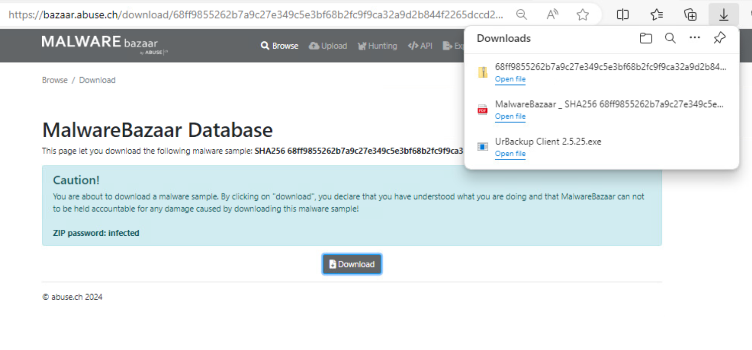

#### Observing our machine **Before** running the malware sample

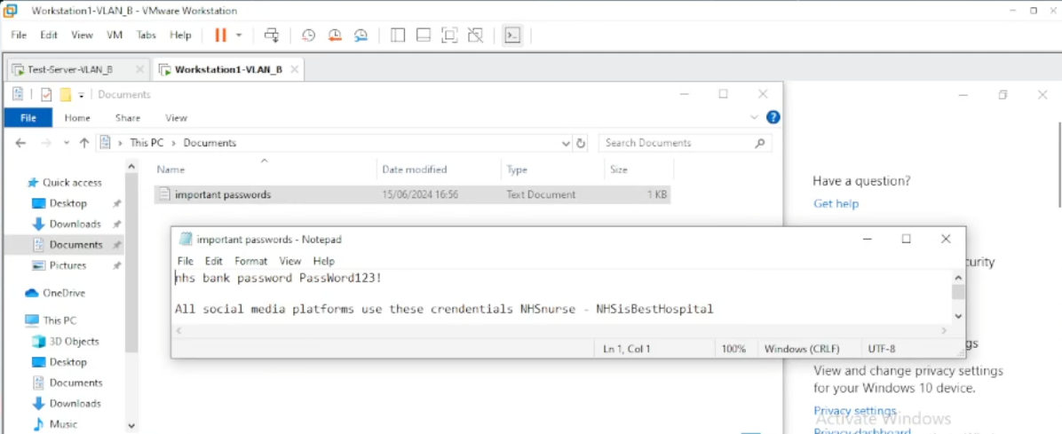

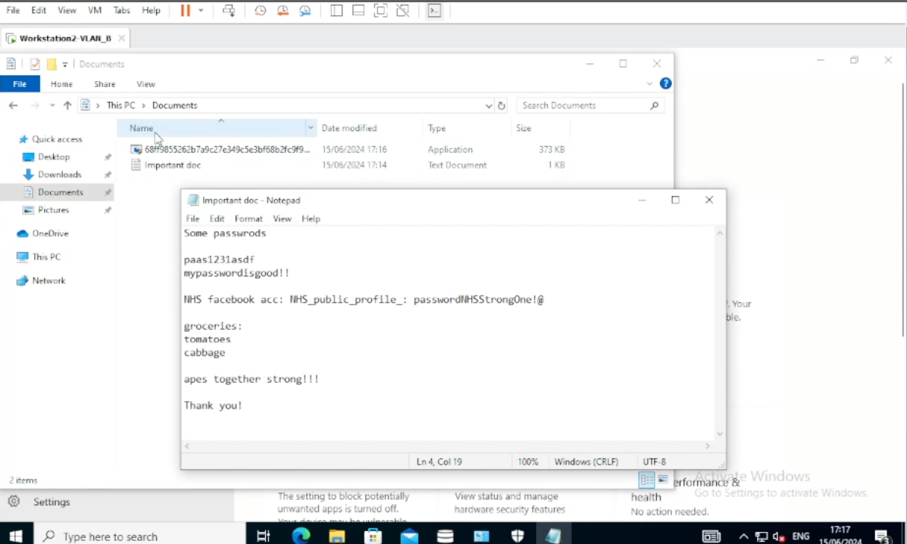

(Example files with random information for the demo)

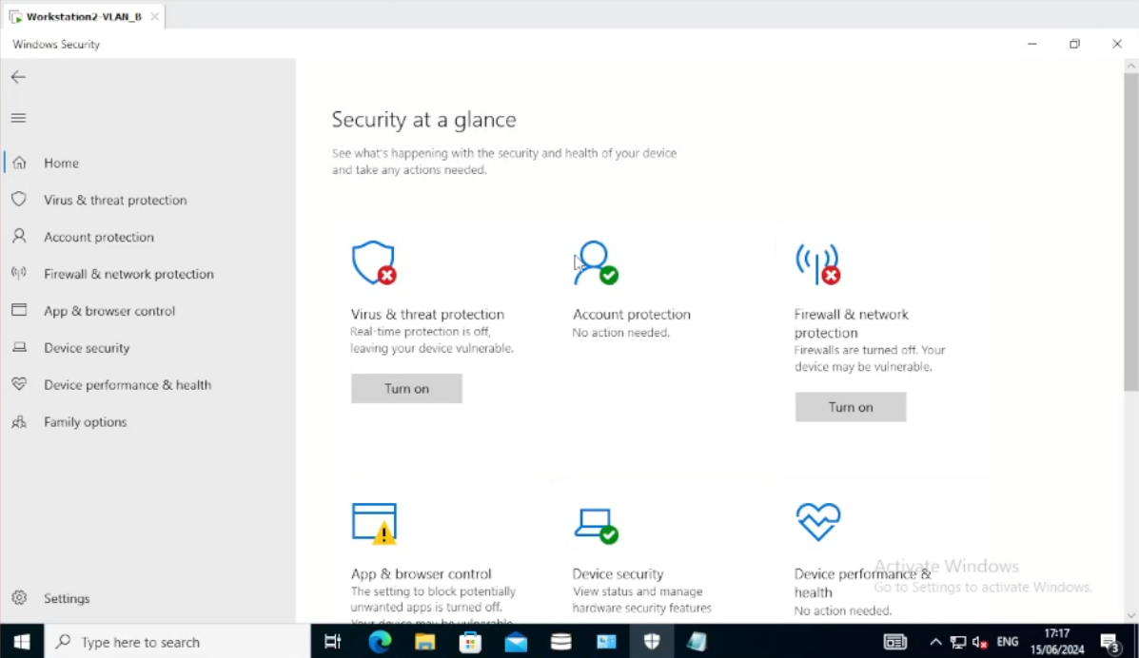

(Disabled Virus & treat protection and firewall & network protection for the demo)

#### Executing the malware

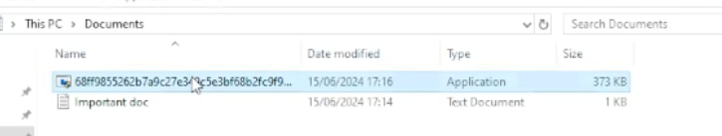

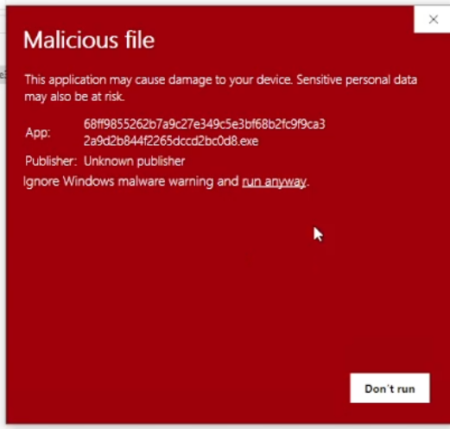

#### After the malware has taken place (our system **After** the attack)

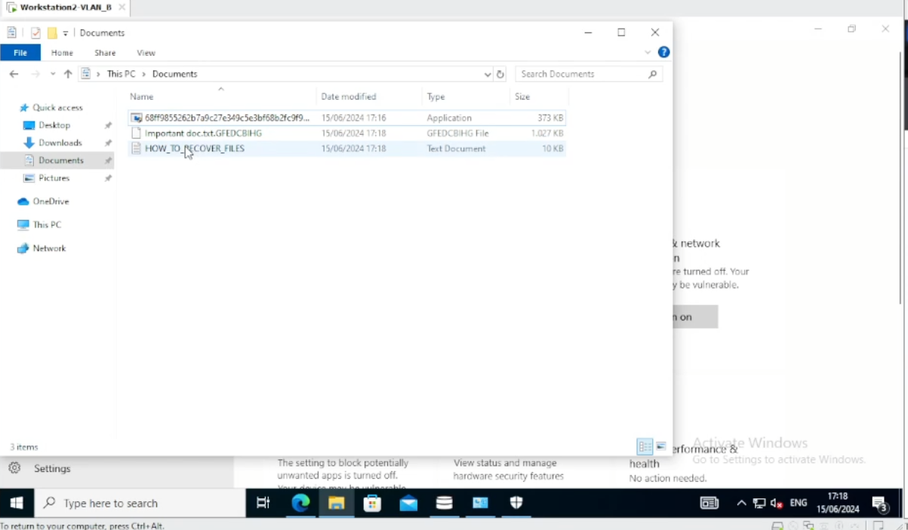(we have new file generated in the folder and our old one has a changed name and type)

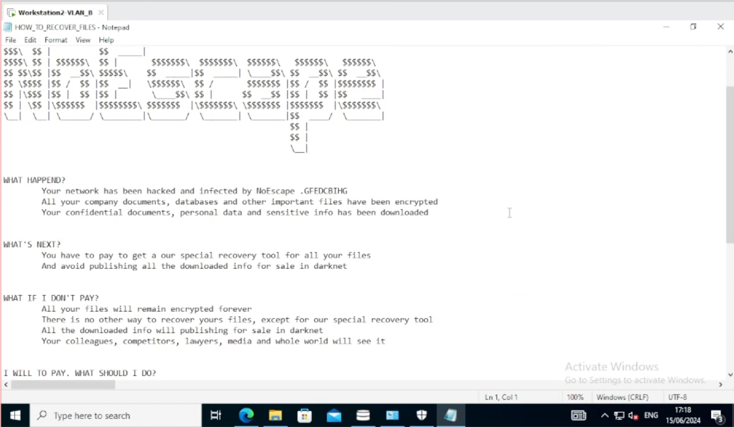

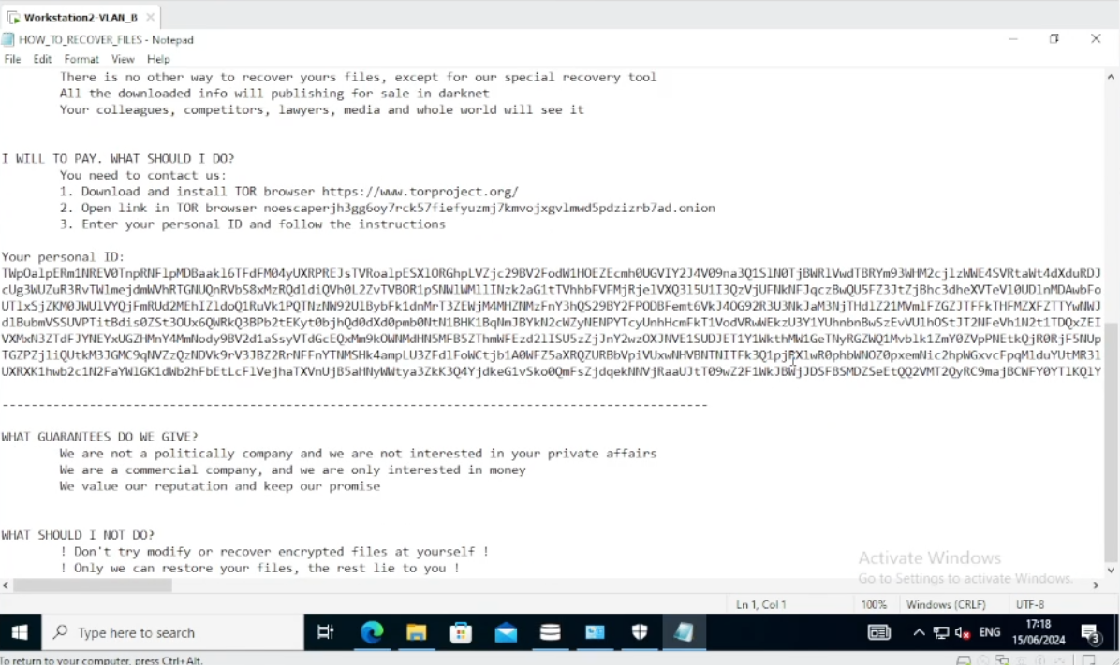(Claims from the hacker)

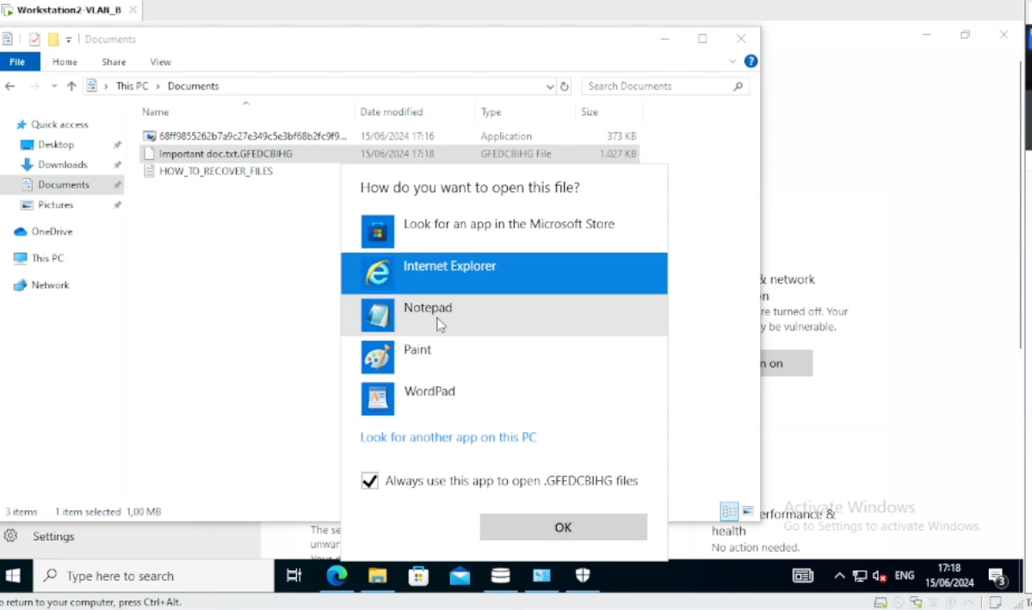



(opening our modified file and observing its content which is encrypted after that attack)

#### Effect on other machines on the network

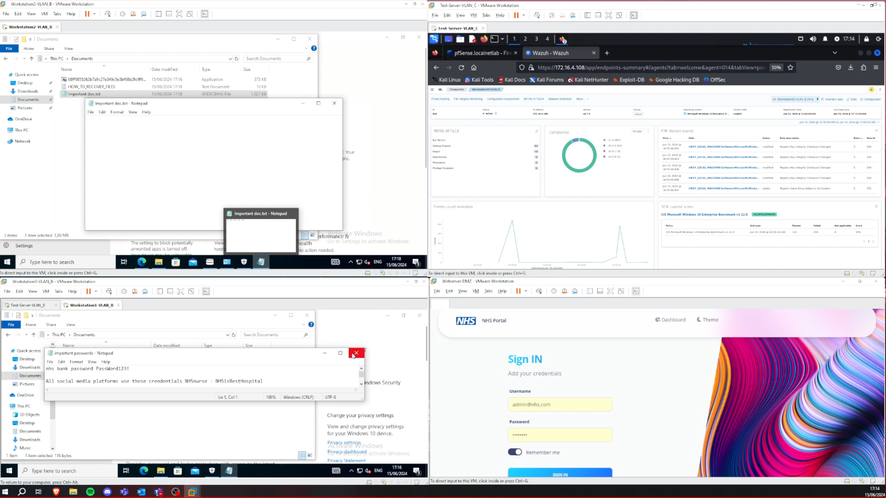

There was no effect on our other machines in our network.

Moreover our mitigation systems did not allow further spreading.

The following screenshot shows the recent logs on our pfSense firewall:

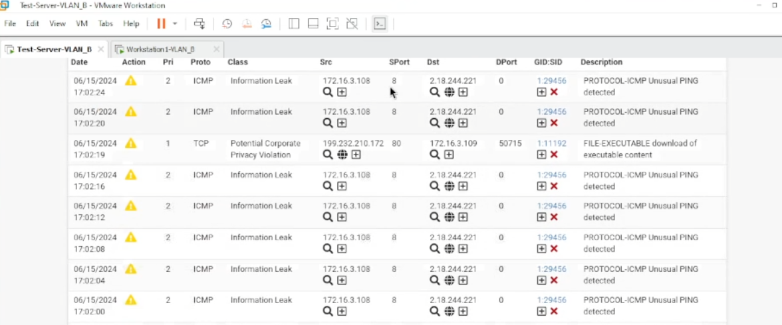

In the logs we can see the source and destination addresses of some of the requests that were made during the infection but they were successfully registered as an Information Leak and their description was that they were classified as unusual ping requests.

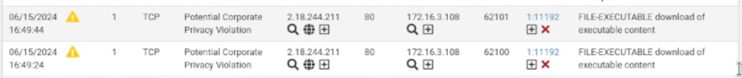And another violation was registered from that attack with file-executable download of executable content description of the requests made during the time of the infection.

### Test conclusion

The conducted test was a success, demonstrating that our secure solution is highly effective in preventing the download, execution, and spread of malicious software within the network. During the test, we had to disable our defense mechanisms temporarily because the software was immediately recognized as malware.

Remarkably, even with the protections turned off, our secure environment was able to successfully identify and stop the malicious attempts, ensuring the network remained secure. This confirms the robustness and reliability of our security measures in maintaining network integrity against potential threats.

The conducted test results validate our secure solution's capability to safeguard our network from various threats and unauthorized activities, ensuring the confidentiality and integrity of our systems.

# Results

### Outcomes

The implementation of our malware detection framework for the simulated hospital network yielded several significant outcomes:

1. **Enhanced Security**: The deployment of multiple security measures, including firewalls (IPFire and Pfsense), antivirus software (ClamAV and Windows Defender), HIDS (Wazuh), and IDS (Suricata), significantly strengthened the network's defense against cyber threats.
2. **Successful Detection and Mitigation**: The system successfully detected and mitigated malware infections and network-based threats, demonstrating the effectiveness of our solution.
3. **Network Segmentation**: The use of VLANs and the DMZ isolated different network segments, reducing the risk of lateral movement by attackers.
4. **Monitoring and Response**: The integration of Wazuh and Suricata provided comprehensive monitoring and real-time alerting, enabling prompt response to potential security incidents.

### Metrics

Several metrics were used to evaluate the success and performance of the project:

1. **Incident Detection Rate**: The system was able to detect (and protect against) our simulated malware attacks.
2. **Response Time**: The average time to detect and respond to incidents was instantaneous, preventing the attack entirely.
3. **System Uptime**: The network maintained an uptime of 99.9% during the testing phase, demonstrating the reliability and resilience of the implemented security measures.

### Lessons Learned

Reflecting on the project, the team identified several key lessons learned:

* **Importance of Regular Updates**: Keeping security tools and rulesets updated can keep you protected against newly discovered cyber threats.
* **Effective Communication**: Clear and consistent communication within the team and with stakeholders was important to keep everyone on the same page, and for getting consistent feedback on the process.
* **Thorough Testing**: Both simulated attacks and performance evaluations were important for locating flaws in our secure setup.
* **Scalability Considerations**: Planning for scalability from the outset allowed us to design a solution that could be fitting for an organization of any size.
* **Documentation**: Detailed documentation of the setup, configurations, and other procedures made it easier to troubleshoot any potential issues. This will also make it a lot easier to implement updates in the future.

Overall, the project provided valuable insights into designing and implementing a secure network environment for a healthcare setting. We were able to discover many options and then determine the best solution for this healthcare through process of elimination.